Please return to:  Livy Ellis  Montgomery  Tel: +44 (0)20 7886 3022  Email: livy.ellis@montgomerygroup.com  DEADLINE:  FRIDAY 21 APRIL |  |  | 
 |  | DEMONSTRATION NOTIFICATION
Keep a copy for your files
To be completed by all exhibitors who are carrying out a demonstration on the stand. This activity must be included in your Show Risk Assessment. This should detail in particular the control and monitoring of any safety procedures that need to be put in place. Please ensure the location of the demonstration is indicated on your stand plan. If your stand is a shell scheme please provide a layout plan with this form.

Give a Description of the Demonstration/s Click here to enter text.
Please state which days the demonstration/s will happen (for promotional purposes) | Tuesday Wednesday  Thursday
Please state what time the demonstration/s will happen (for promotional purposes) | Enter a time here
Approximate frequency of demonstrations | Every Enter a number here minutes
What type of waste will your demonstration produce? | Enter type of waste here
If your demonstration requires dust extraction has this been organised | YES☐ /NO☐
Have you ordered appropriate compressed air / water & waste facilities? | YES☐ / NO☐
Type of equipment to be used in demonstration | Enter equipment here
If you are using microphones, please advise the channel frequency you are using to ensure that there is no cross over with other demonstrations | Enter channel frequency here

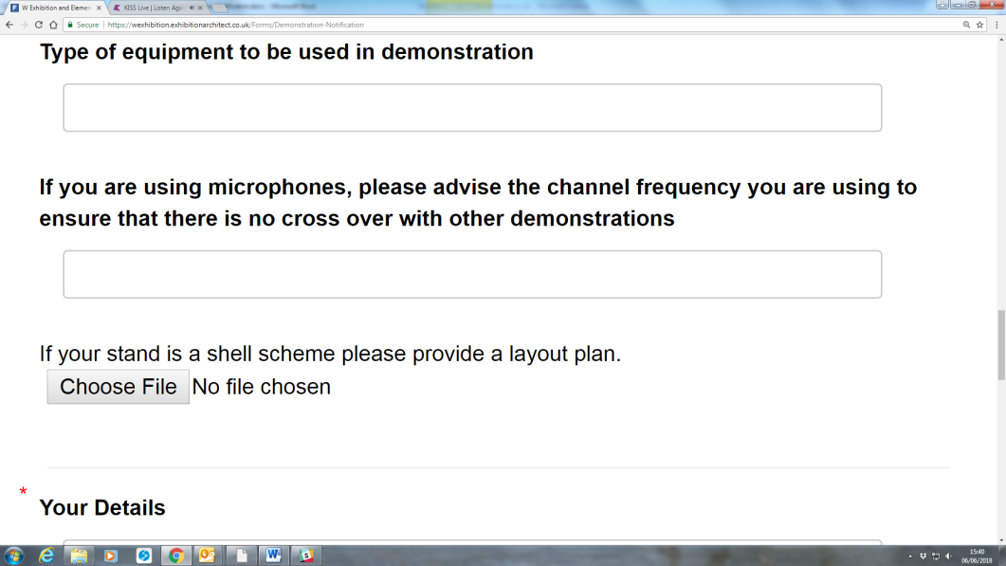
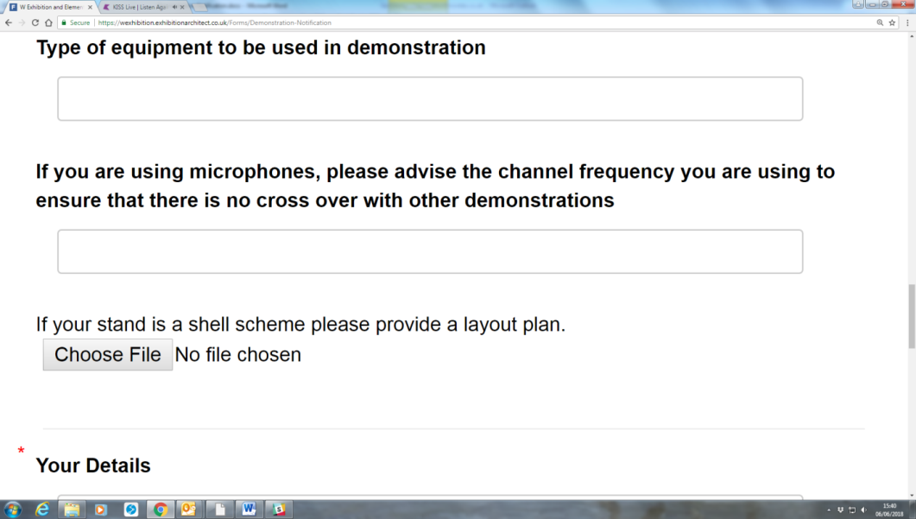
Please upload an image of the product/s being demonstrated (for marketing purposes). If you have more than 4 products please send the images directly to ana-maria.butaru@montgomerygroup.com.
Your Details: Click here to enter text. Stand N° Enter a number here
Company Name Enter company name here
Contact Enter contact name here
Email Enter email here
Tel No Enter a number here
Date Enter a number here

